FAGLL03-G/L LINE ITEM DISPLAY - FOR IDENTIFYING OPEN ITEMS



This simulation focuses on how to find Open/Cleared items in T-Code FAGLL03-G/L Line Item Display.

For general functionalities of FAGLL03 report, please refer to a separate simulation FAGLL03-General Purpose.

Click to continue.

Explanation | Screenshot
[1] FAGLL03 is now entered in the Transaction box. | 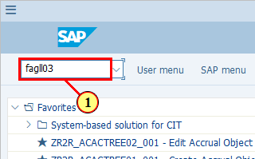
  This is the G/L accounts for which you wish to check Open/Cleared items. So it should be G/L accounts with one the following settings in their G/L Master Data:  - Open Item Management  - Clearing Specific to Ledger Groups  You can of course use a range. In this case the system will display all G/L line items in this account range. Then you will need to filter for accounts to see specific items in specific accounts.  We will be using a range in this demo.  [2] The G/L account field is filled out. | 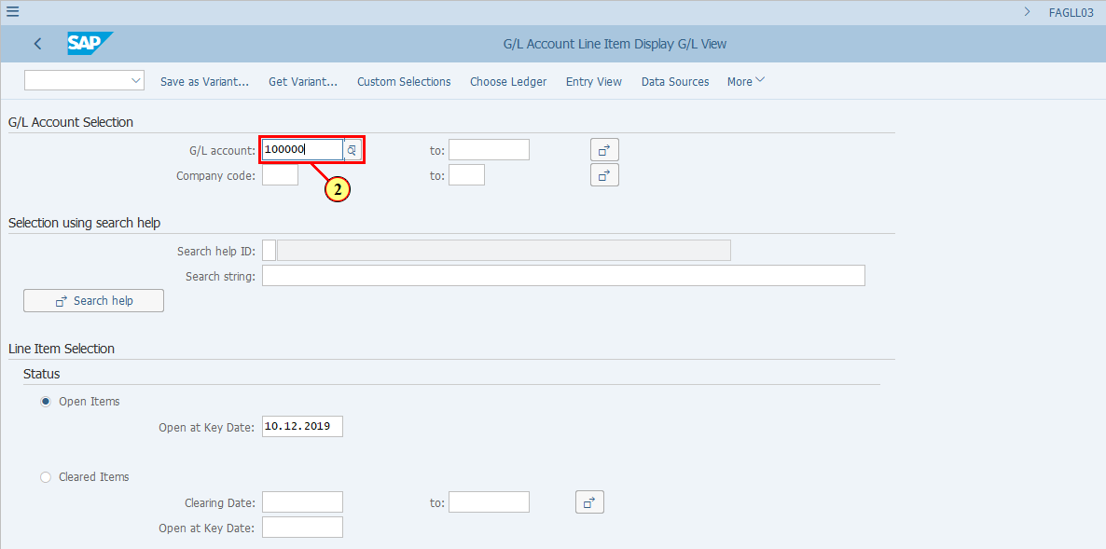
[3] The to field is filled out. | 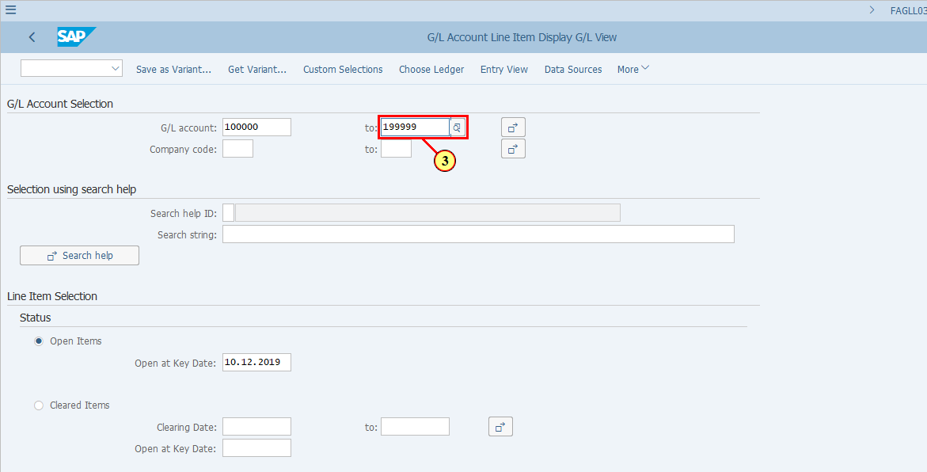
[4] The Company code field is filled out. | 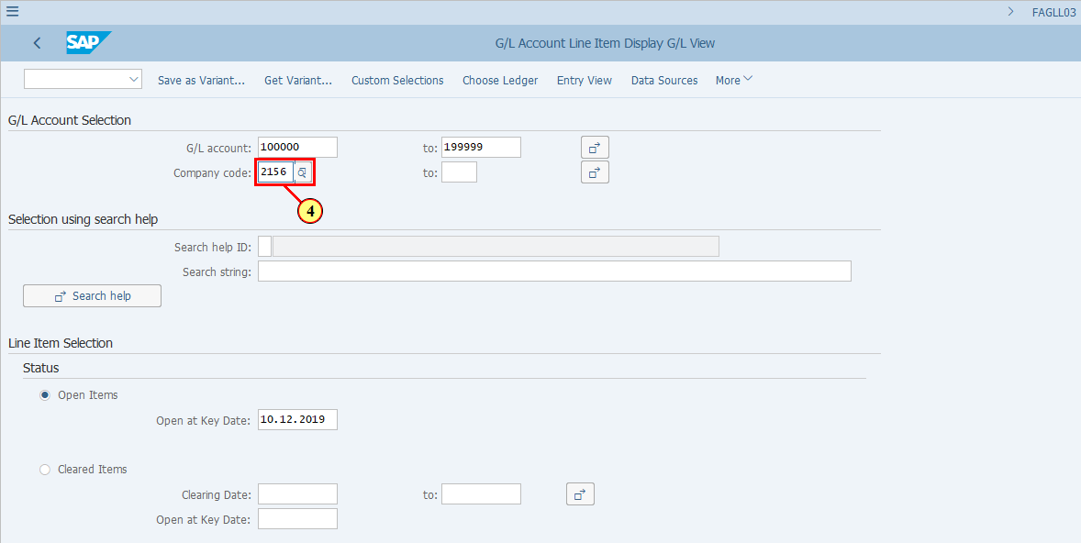
  Select Open Items if you wish to display Open Items only.  Select Cleared Items if you wish to display Cleared Items only.  Select All items if you wish to display All items.  In this demonstration we will be selecting Open Items. You must provide a Open at Key Date when you select this option.  [5] The Open at Key Date field is filled out. | 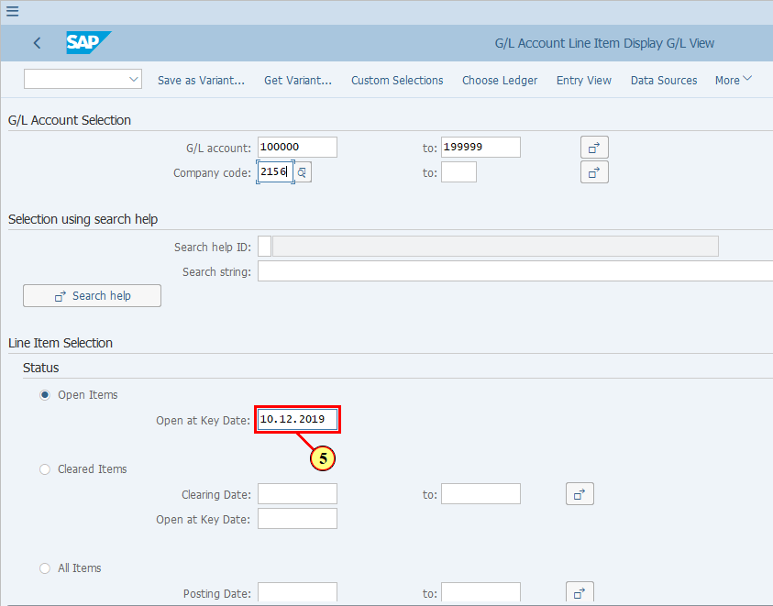
[6] Click Execute .  You can also press F8. | 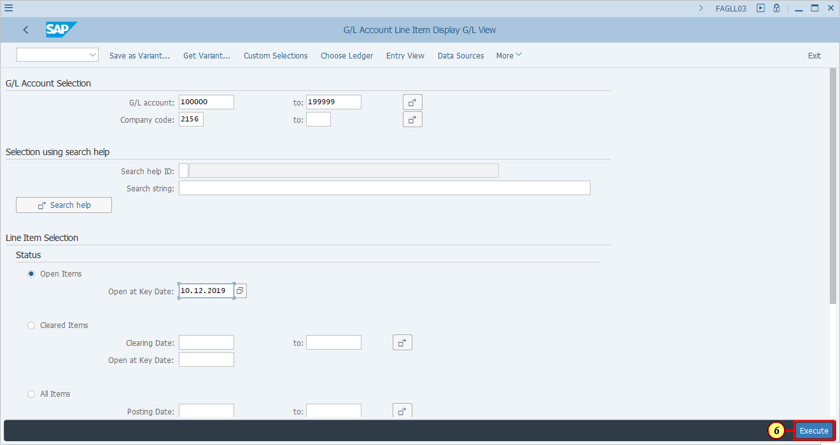
[7] Click Change Layout... .  You can also press Ctrl+F8. | 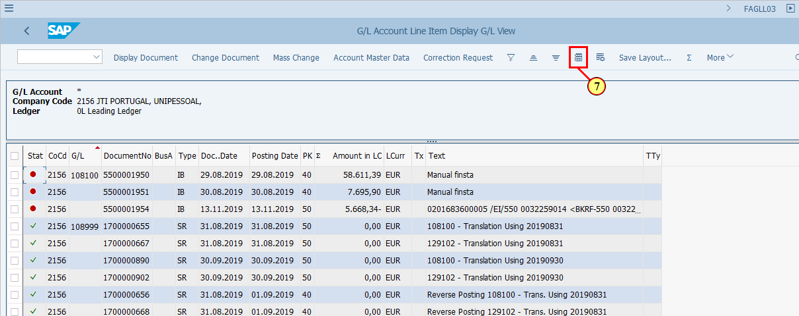
  There are specific columns you need to add to your layout in order to be able to identify Open/Cleared Items in a Parallel Ledger environment.  1. The Cleared/Open Items Symbol shows you whether an item is open (red circle) or cleared (green square).  2. Ledger and Ledger Group helps you to decide whether you should clear an open item ledger-through or in specific ledger groups.  [8] Click Column Name . | 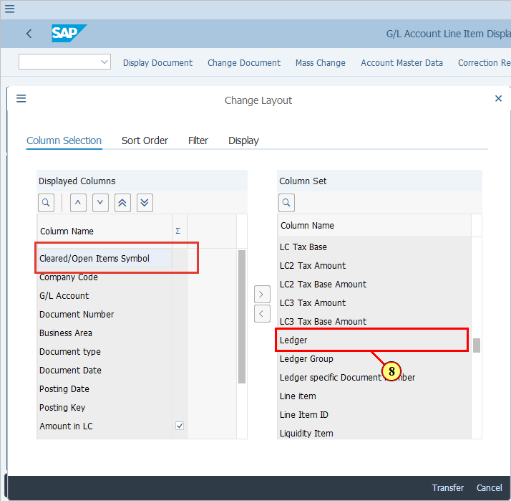
[9] Click Column Name .  Press Ctrl key while performing the action. | 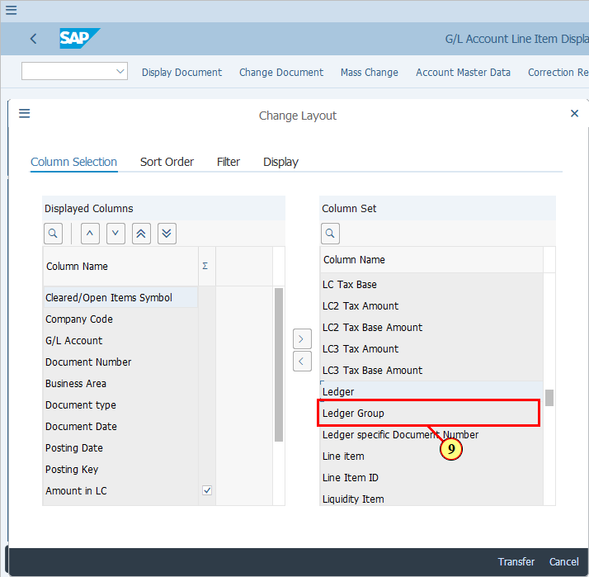
[10] Click Column Name . | 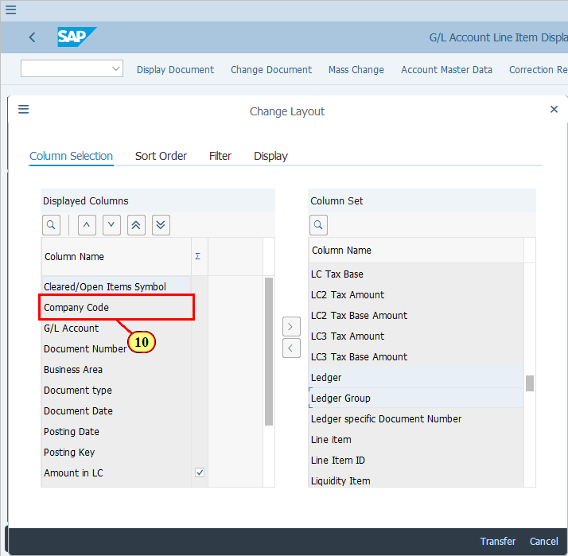
[11] Click here (or F7) to move the selected columns to display. | 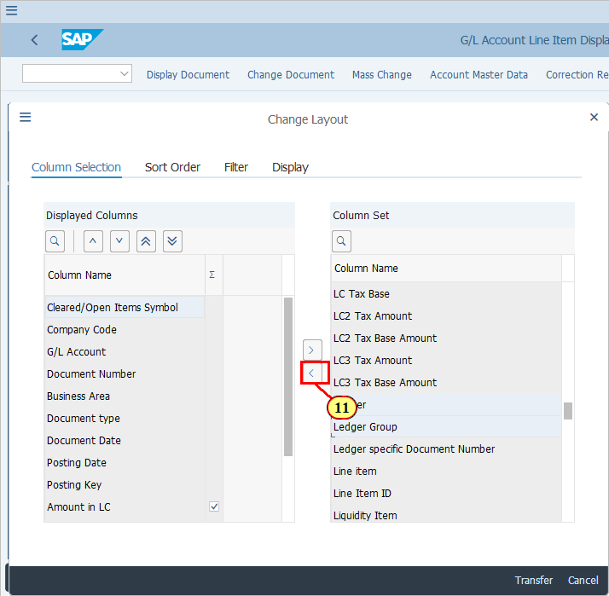
 | 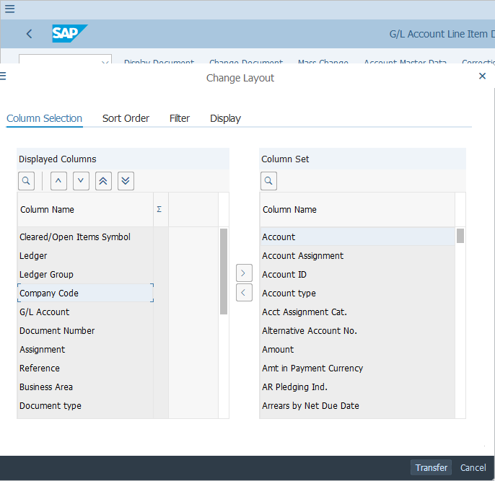
[12] Click Transfer to continue. | 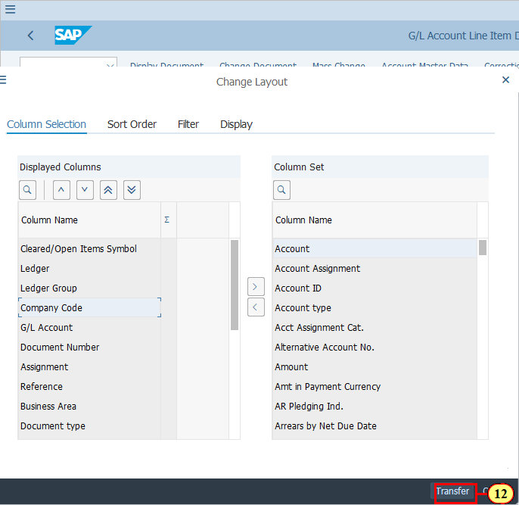
  If you have selected a range as shown in this example, you will see both open items and items which have a status called "Posted" (Green tick). These are for G/L accounts which are not set as either Open Item managed or Clearing Specific to Ledger Groups.  To filter only open items, filer column "Status".  [13] Click . | 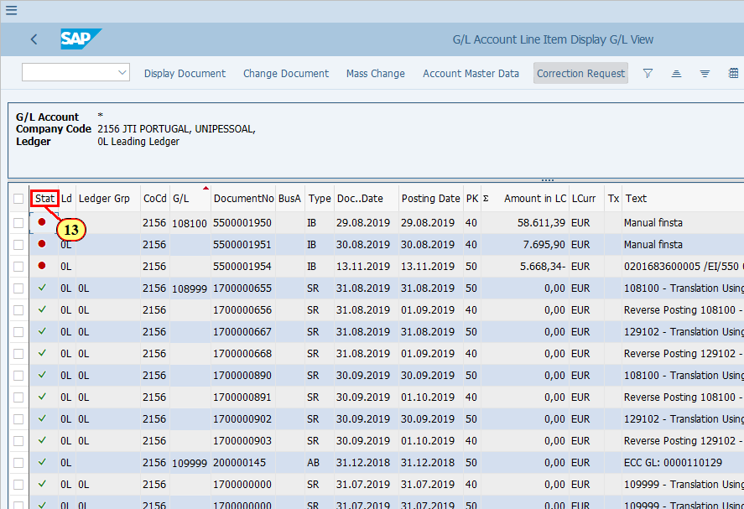
[14] Click Set Filter .  You can also press Ctrl+Shift+F2. | 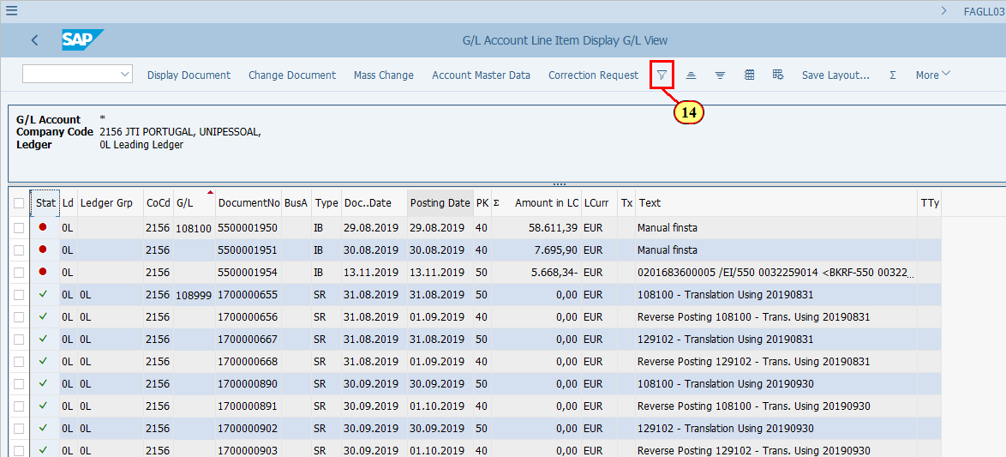
[15] Click next to field Cleared/Open Items Symbol to open a dropdown list of this field | 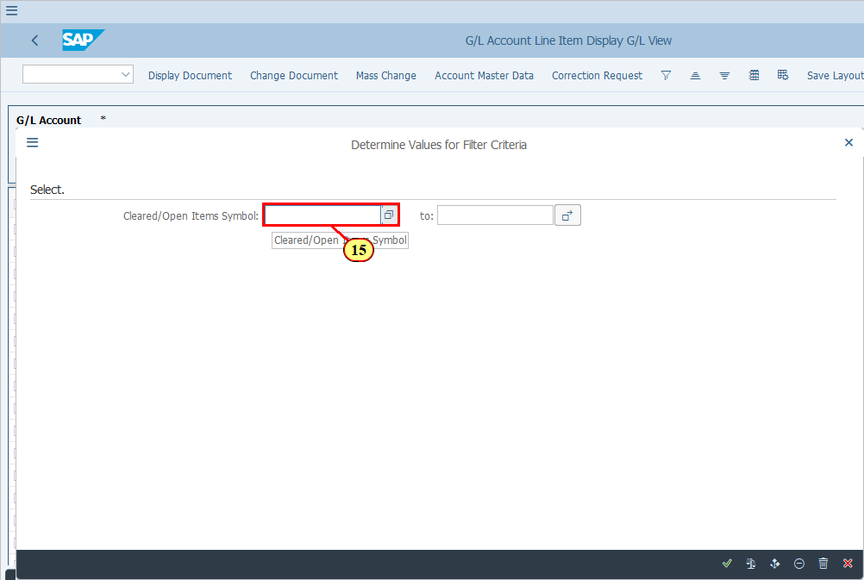
[16] Click on the Open symbol (red circle) | 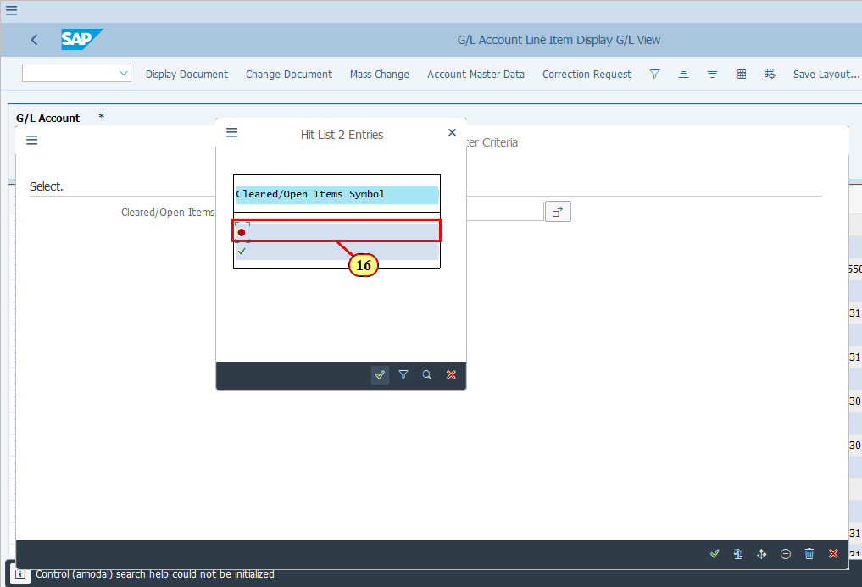
[17] Click Copy .  You can also press Enter. | 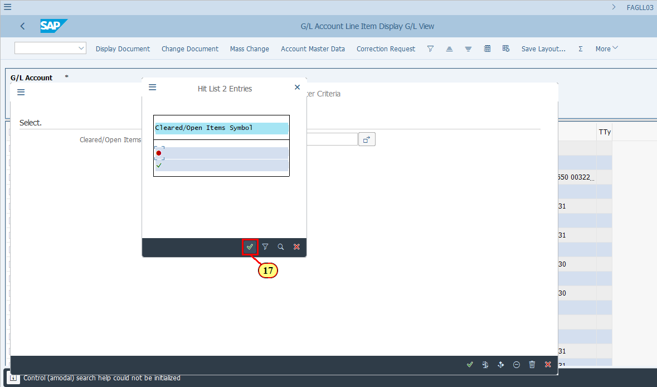
[18] Click Execute .  You can also press Enter. | 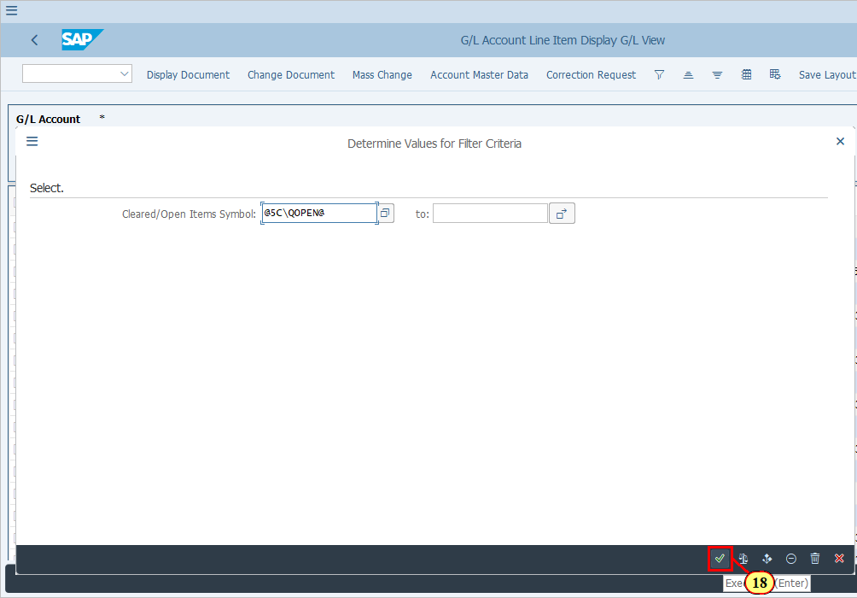
  The following columns may also help you to identify which open items can be cleared:  - Assignment (For certain accounts Assignment field represents a unique code, e.g. it could be Invoice number, contract number, PO+Item etc.. In these cases if you do a subtotal by Assignment you will be able to tell whether the items associated to one invoice/contract/PO item can be cleared.)  - Reference (This may work similar as Assignment for certain accounts.)  - Amounts in DC, LC, Group Currency, Group Currency/Grp Valuation (These represents DC, LC1, LC2 and LC3 respectively. Note that LC3 is only available in Ledger 0L)  For open items to be able to be cleared, they must add up to zero in one of the above currencies within the same Ledger Group.. Detailed examples are available in Parallel Ledger training presentation.  [19] You are recommended to save a layout for checking Open items.  Click Save Layout... .  You can also press Ctrl+F12. | 